|  |
| --- |
| **MINI PROJECT REPORT**    **On**    **E-COMMERCE WEBSITE (Computer Hardware)**      **Submitted by**      **PRASHANTN SUMAN**  **171500231**  **NITIN KUMAR SRIVASTAVA**  **171500208**  **VAIBHAV SAXENA**  **171500368**  **ROHAN YADAV**  **171500266**  Department of Computer Engineering & Applications **Institute of Engineering & Technology**        **Submitted to**  **Mr. Pankaj Kapoor**      **GLA University**  **Mathura- 281406,**  **2019-20** |



**Department of computer Engineering and Applications**

**GLA University, Mathura**

**17**

**km. Stone NH**

**#2, Mathura**

**-**

**Delhi Road, P.O.**

**–**

**Chaumuha,**

**Mathura**

**–**

**281406**



# Declaration

We hereby declare that the work which is being presented in the Mini Project II “E-Commerce Website (Computer Hardware)**”,** in partial fulfillment of the requirements for Mini Project is an authentic record of our own work carried under the supervision of **Mr. Pankaj Kapoor** of “Dept. of Computer Science And Engineering, GLA UNIVERSITY,MATHURA”.

**Signature of Candidates:**

**Name of Candidate:** Prashant Suman ,Nitin Kumar Srivastava , Vaibhav Saxena, Rohan Yadav

**Roll. No.** : 171500231,171500208,171500368,171500266

**Course:** B.tech

**Year:** 3rd year

**Semester:** V

# SYNOPSIS

**Student Information:**

|  |  |
| --- | --- |
| Name: Prashant Suman,Nitin  Kumar Srivastava, Vaibhav Saxena, Rohan Yadav | University Roll. No.171500231,171500208, 171500368,171500266 |
| Mobile:  9304246019,9455836984 | Email:prashant.suman_cs17@gla.ac.in,nitin.srivastava _cs17@gla.ac.in,vaibhav.saxena_cs17@gla.ac.in,rohan.yadav_cs17@gla.ac.in |

**Information about Organization:**

|  |  |
| --- | --- |
| Organization Name with full Address | 17km Stone, NH-2, Mathura-Delhi Road Mathura,  Chaumuhan, Uttar Pradesh 281406 |
| Contact Person | Pankaj Kapoor |

**Project Information:**

|  |  |
| --- | --- |
| Title Of Project | E-Commerce Website(Computer Hardware) |
| Technical Details | Hardware Requirements: computer system with  minimum 4GB of RAM    Software Requirements: Bracket.    Language used:HTML,CSS JAVASCRIPT |
| Training Implementation Details | Fully Implemented |

# ACKNOWLEDGEMENTS

We found this golden chance to acknowledge all those people who had blessed, encouraged and supported us technically and morally through all the phases of our project. We take this opportunity to express our profound sense of gratitude. We thank all mighty GOD for giving us this opportunity to express gratitude to all those who helped me in successful completion of this project. We pay our immense gratitude to **Mr. Pankaj Kapoor,** Dept. of Computer Science And Engineering for providing help and giving us a chance for showing our skills through continued support and co-operation during the concerned project. We deeply indebted to staff of Computer Dept., for their sincere co-operation and sparing time to answer questionnaires with their selfless efforts and co-operation because of which we are able to complete this project. We are deeply indebted to our parents who have always been a perennial source of information, encouragement and inspiration for entire education required.

**Prashant Suman**

**Nitin Kumar Srivastava**

**Vaibhav Saxena**

**Rohan Yadav**

# ABSTRACT

Our project is Computer Hardware. This is a. website which helps user to find and buy all type of product on Internet. It is useful in the way that it makes an easier way to buy and item online. Computer Hardware is an interactive e-commerce solution providing users with an opportunity to buy different product. Computer Hardware is the first online platform which deals with all type of product.

In this website we have basically 2 modules. The first module includes the customer module and second module includes admin module. The customer have to register for shopping and viewing product. The registered customer can view details product and can buy according to their needs.

He/she has to pay and will get home delivery.

The admin module contains the access of admin page on the website. The admin can change everything in the website. He have the ability to add, delete_ and update any information regarding the product.

# Table of Contents

Acknowledgment 3

Abstract 4

1. **Introduction** (This chapter must describe introduction about your project) **6** 
   * 1. Motivation and Overview 6
2. **Software Requirement Analysis 7** 
   * 1. Define the problem 7
     2. Define the modules and their functionalities (SRS) 7
3. **Software Design** 8
4. **Webpage Designing** 10
5. **Implementation** 11
6. **User Interface** 18
7. **Bibliography** 23
8. **Conclusion/Future Scope** 24

# INTRODUCTION

## 1.1 Motivation and Overview

Computer Hardware is an interactive e-commerce solution providing users with an opportunity to buying different product. Computer Hardware is the first online platform which deals with new and stylish product, we deliver a constructive service to each and every person of country to furnish their needs in terms of styling, fashion and reading material etc. by providing them with an online platform where they can buy for affordable price and even they can sell their old product on our website and also get product on paynow later option.Computer Hardware provides users with wide range of pre-owned product which getacheck based on their condition and fixed to its best and delivered to consumer's doorsteps

## 1.2 Objective

Ordering Shopping is the process whereby consumers directly buy goods andservices without any intermediary service over the 'internet’. The goal of this website is to develop a web based interface for user of our country,the website would be easy to use and hence the shopping experience pleasant for the Men,Women.The main goal of this website are:

1.To develop an easy to use web based interface where user and can search for products,view a complete description of the product and order the product.

2.A user can buy and sell product from home.

3.A user can get paynow later option for product.

# Software Requirement Analysis

## 2.1 Problem definition

The selection of hardware is very important in the existence and proper working of any software.

When selecting hardware, the size and requirements are also important.

|  |  |
| --- | --- |
| Processor | Intel CORE i5 |
| RAM | **4.0** **GB** |
| Hard Disk Drive | **500** **GB** |

## 2.2 Software Requirements

|  |  |
| --- | --- |
| **Number** | **Description** |
| 1 | Windows 7,8,10 |
| 2 | HTML/CSS//JavaScript/ Bootstrap. |
| 3 | Apache server/ XAMPSERVER |
| 4 | PHP 5.5.38 |
| 4 | MySQL |

# SOFTWARE DESIGN

## 3.1 SYSTEM DESIGN

**Web** **development** is a broad term for the work involved in developing a [web site f](https://en.wikipedia.org/wiki/Web_site)or the [Internet (World Wide Web) o](https://en.wikipedia.org/wiki/Internet)r an [intranet (](https://en.wikipedia.org/wiki/Intranet)a private network). Web development can range from developing the simplest static single page of [plain text t](https://en.wikipedia.org/wiki/Plain_text)o the most complex web-based [internet applications, electronic businesses, a](https://en.wikipedia.org/wiki/Internet_application)nd [social network services. A](https://en.wikipedia.org/wiki/Social_network_service) more comprehensive list of tasks to which web development commonly refers, may include [web engineering, web design,](https://en.wikipedia.org/wiki/Web_engineering) [web content development, c](https://en.wikipedia.org/wiki/Web_content_development)lient liaison, [client-side/s](https://en.wikipedia.org/wiki/Client-side_scripting)ide scripting, [web server a](https://en.wikipedia.org/wiki/Web_server)nd [network security c](https://en.wikipedia.org/wiki/Network_security)onfiguration, and [e-commerce d](https://en.wikipedia.org/wiki/E-commerce)evelopment. Among web professionals, "web development" usually refers to the main non-design aspects of building web sites: writing [markup a](https://en.wikipedia.org/wiki/Markup_language)nd [coding. M](https://en.wikipedia.org/wiki/Computer_programming)ost recently Web development has come to mean the creation of [content management systems o](https://en.wikipedia.org/wiki/Content_management_system)r CMS. These CMS can be made from scratch, proprietary or open source. In broad terms the CMS acts as middleware between the database and the user through the browser. A principle benefit of a CMS is that it allows non-technical people to make changes to their web site without having technical knowledge.

For larger organizations and businesses, web development teams can consist of hundreds of people [(web developers) a](https://en.wikipedia.org/wiki/Web_developer)nd follow standard methods like [Agile methodologies](https://en.wikipedia.org/wiki/Agile_software_development) while developing websites. Smaller organizations may only require a single permanent or contracting developer, or secondary assignment to related job positions such as a [graphic designer o](https://en.wikipedia.org/wiki/Graphic_designer)r [information systems t](https://en.wikipedia.org/wiki/Information_systems)echnician. Web development may be a collaborative effort between departments rather than the domain of a designated department. There are three kind of web developer specialization: front-end developer, back-end developer, and full-stack developer.

## 3.2 IMPLEMENTATION

A **website** is a collection of related [web pages, i](https://en.wikipedia.org/wiki/Web_page)ncluding [multimedia c](https://en.wikipedia.org/wiki/Multimedia)ontent, typically identified with a common [domain name, a](https://en.wikipedia.org/wiki/Domain_name)nd published on at least one [web server. A](https://en.wikipedia.org/wiki/Web_server) website may be accessible via a public [Internet Protocol (](https://en.wikipedia.org/wiki/Internet_Protocol)IP) network, such as the [Internet, o](https://en.wikipedia.org/wiki/Internet)r a private [local area network (](https://en.wikipedia.org/wiki/Local_area_network)LAN), by referencing a [uniform resource locator (](https://en.wikipedia.org/wiki/URL)URL) that identifies the site.

Websites have many functions and can be used in various fashions; a website can be a [personal website, a](https://en.wikipedia.org/wiki/Personal_website) commercial website for a company, a [government website o](https://en.wikipedia.org/wiki/E-Government)r a [non-profit organization w](https://en.wikipedia.org/wiki/Nonprofit_organization)ebsite. Websites are typically dedicated to a particular topic or purpose, ranging from entertainment and [social networking t](https://en.wikipedia.org/wiki/Social_networking)o providing news and education. All publicly accessible websites collectively constitute the [World Wide Web, w](https://en.wikipedia.org/wiki/World_Wide_Web)hile private websites, such as a company's website for its employees, and are typically a part of an [intranet.](https://en.wikipedia.org/wiki/Intranet)

Web pages, which are the [building blocks o](https://en.wikipedia.org/wiki/Building_block)f websites, are [documents, t](https://en.wikipedia.org/wiki/Document)ypically composed in [plain text i](https://en.wikipedia.org/wiki/Plain_text)nterspersed with formatting instructions of Hypertext Markup Language [(HTML, XHTML).](https://en.wikipedia.org/wiki/HTML) They may incorporate elements from other websites with suitable [markup anchors. W](https://en.wikipedia.org/wiki/HTML_anchor)eb pages are accessed and transported with the [Hypertext Transfer Protocol (](https://en.wikipedia.org/wiki/Hypertext_Transfer_Protocol)HTTP), which may optionally employ encryption [(HTTP Secure, H](https://en.wikipedia.org/wiki/HTTP_Secure)TTPS) to provide security and privacy for the user. The user's application, often a [web browser, r](https://en.wikipedia.org/wiki/Web_browser)enders the page content according to its HTML markup instructions onto a [display terminal.](https://en.wikipedia.org/wiki/Computer_monitor)

[Hyperlinking b](https://en.wikipedia.org/wiki/Hyperlink)etween web pages conveys to the reader the [site structure a](https://en.wikipedia.org/wiki/Site_map)nd guides the navigation of the site, which often starts with a [home page c](https://en.wikipedia.org/wiki/Home_page)ontaining a directory of the site [web content. S](https://en.wikipedia.org/wiki/Web_content)ome websites require user registration or [subscription t](https://en.wikipedia.org/wiki/Subscription)o access content. Examples of [subscription websites i](https://en.wikipedia.org/wiki/Paywall)nclude many business sites, news websites, [academic journal w](https://en.wikipedia.org/wiki/Academic_journal)ebsites, gaming websites, file-sharing websites, [message boards, w](https://en.wikipedia.org/wiki/Internet_forum)ebbased [email,](https://en.wikipedia.org/wiki/Email) [social networking w](https://en.wikipedia.org/wiki/Social_networking)ebsites, websites providing real-time [stock market d](https://en.wikipedia.org/wiki/Stock_market)ata, as well as sites providing various other services. As of 2016 [end users c](https://en.wikipedia.org/wiki/End_user)an access websites on a range of devices, including [desktop a](https://en.wikipedia.org/wiki/Desktop_computer)nd [laptop computers, tablet](https://en.wikipedia.org/wiki/Laptop) [computers, smartphones a](https://en.wikipedia.org/wiki/Tablet_computer)nd [smart TVs.](https://en.wikipedia.org/wiki/Smart_TV)

A web site consists of web pages which are interconnected to each other and contain various data and functionalities.

**WEBPAGE DESIGINING**

Creating a web site requires multiple steps which includes the following: o Creating a UI(User interface) o Scripting(Both at server end and client end.

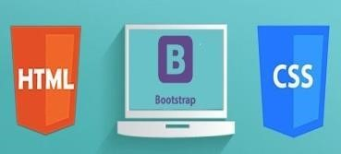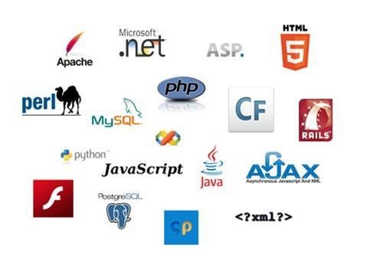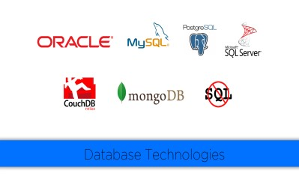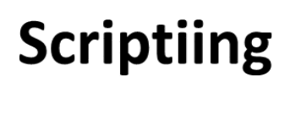

**Web**

**Site**

**UI**

**Data**

**Base**

**Fig**

**4**

**.**

**1**

**WEBSITE**

# IMPLEMENTATION

## 5.1 UI DEVELOPMENT

Technologies that are mostly used to develop a User Interface are:

**Hypertext** **Markup** **Language** (**HTML**) is the standard [markup language f](https://en.wikipedia.org/wiki/Markup_language)or creating [web pages a](https://en.wikipedia.org/wiki/Web_page)nd [web applications. W](https://en.wikipedia.org/wiki/Web_application)ith [Cascading Style Sheets (](https://en.wikipedia.org/wiki/Cascading_Style_Sheets)CSS) and [JavaScript i](https://en.wikipedia.org/wiki/JavaScript)t forms a triad of cornerstone technologies for the [World Wide Web. Web browsers](https://en.wikipedia.org/wiki/World_Wide_Web) receive HTML documents from a [webserver o](https://en.wikipedia.org/wiki/Webserver)r from local storage and render them into multimedia web pages. HTML describes the structure of a web page [semantically a](https://en.wikipedia.org/wiki/Semantic)nd originally included cues for the appearance of the document.

[HTML elements a](https://en.wikipedia.org/wiki/HTML_element)re the building blocks of HTML pages. With HTML constructs, [images a](https://en.wikipedia.org/wiki/Img_%28HTML_element%29)nd other objects, such as [interactive forms, m](https://en.wikipedia.org/wiki/Fieldset)ay be embedded into the rendered page. It provides a means to create [structured documents b](https://en.wikipedia.org/wiki/Structured_document)y denoting structural [semantics f](https://en.wikipedia.org/wiki/Semantics)or text such as headings, paragraphs, lists, [links, q](https://en.wikipedia.org/wiki/Hyperlink)uotes and other items. HTML elements are delineated by tags, written using [angle brackets. T](https://en.wikipedia.org/wiki/Bracket#Angle_brackets)ags such as <img /> and <input /> introduce content into the page directly. Others such as <p>...</p> surround and provide information about document text and may include other tags as sub-elements. Browsers do not display the HTML tags, but use them to interpret the content of the page.

HTML can embed programs written in a [scripting language s](https://en.wikipedia.org/wiki/Scripting_language)uch as [JavaScript w](https://en.wikipedia.org/wiki/JavaScript)hich affect the behavior and content of web pages. Inclusion of CSS defines the look and layout of content. The [World Wide Web Consortium (](https://en.wikipedia.org/wiki/World_Wide_Web_Consortium)W3C), maintainer of both the HTML and the CSS standards, has encouraged the use of CSS over explicit presentational HTML since 1997.

HTML markup consists of several key components, including those called tags (and their attributes), character-based data types, character references and entity references. HTML tags most commonly come in pairs like <h1> and </h1>, although some represent empty elements and so are unpaired, for example <img>. The first tag in such a pair is the start tag, and the second is the end tag (they are also called opening tags and closing tags).

Another important component is the HTML [document type declaration, w](https://en.wikipedia.org/wiki/Document_type_declaration)hich triggers [standards mode r](https://en.wikipedia.org/wiki/Standards_mode)endering.

The following is an example of the classic [Hello world program, a](https://en.wikipedia.org/wiki/Hello_world_program) common test employed for comparing [programming languages, scripting languages a](https://en.wikipedia.org/wiki/Programming_language)nd [markup languages.](https://en.wikipedia.org/wiki/Markup_language)  This example is made using 9 [lines of code:](https://en.wikipedia.org/wiki/Lines_of_code)

## General Syntax of HTML

<!DOCTYPE html> <html> <he ad>

<title>This is a title</title> </head> <body>

<p>Hello world!</p> </body>

</html>

(The text between <html> and </html> describes the web page, and the text between <body> and </body> is the visible page content. The markup text "<title>This is a title</title>" defines the browser page title.)

The Document Type Declaration <!DOCTYPE html> is for HTML5. If a declaration is not included, various browsers will revert to ["quirks mode" f](https://en.wikipedia.org/wiki/Quirks_mode)or rendering.

**Cascading** **Style** **Sheets** (**CSS**) is a [style sheet language u](https://en.wikipedia.org/wiki/Style_sheet_language)sed for describing the [presentation o](https://en.wikipedia.org/wiki/Presentation_semantics)f a document written in a [markup language. A](https://en.wikipedia.org/wiki/Markup_language)lthough most often used to set the visual style of [web pages a](https://en.wikipedia.org/wiki/Web_page)nd user interfaces written in [HTML a](https://en.wikipedia.org/wiki/HTML)nd [XHTML, t](https://en.wikipedia.org/wiki/XHTML)he language can be applied to any [XML d](https://en.wikipedia.org/wiki/XML)ocument, including [plain XML, SVG a](https://en.wikipedia.org/wiki/Plain_Old_XML)nd [XUL,](https://en.wikipedia.org/wiki/XUL) and is applicable to rendering in [speech, o](https://en.wikipedia.org/wiki/Speech_synthesis)r on other media. Along with HTML and [JavaScript,](https://en.wikipedia.org/wiki/JavaScript) [C](https://en.wikipedia.org/wiki/JavaScript)SS is a cornerstone technology used by most websites to create visually engaging webpages, user interfaces for [web applications, a](https://en.wikipedia.org/wiki/Web_applications)nd user interfaces for many mobile applications.

CSS is designed primarily to enable the separation of presentation and content, including aspects such as the [layout, colors, a](https://en.wikipedia.org/wiki/Page_layout)nd [fonts. T](https://en.wikipedia.org/wiki/Typeface)his separation can improve content [accessibility, p](https://en.wikipedia.org/wiki/Accessibility)rovide more flexibility and control in the specification of presentation characteristics, enable multiple HTML pages to share formatting by specifying the relevant CSS in a separate .css file, and reduce complexity and repetition in the structural content.

Separation of formatting and content makes it possible to present the same markup page in different styles for different rendering methods, such as on-screen, in print, by voice (via speech-based browser or [screen reader),](https://en.wikipedia.org/wiki/Screen_reader) and on [Braille-based](https://en.wikipedia.org/wiki/Braille_display) [t](https://en.wikipedia.org/wiki/Braille_display)actile devices. It can also display

the web page differently depending on the screen size or viewing device. Readers can also specify a different style sheet, such as a CSS file stored on their own computer, to override the one the author specified.

Changes to the [graphic design](https://en.wikipedia.org/wiki/Graphic_design) [o](https://en.wikipedia.org/wiki/Graphic_design)f a document (or hundreds of documents) can be applied quickly and easily, by editing a few lines in the CSS file they use, rather than by changing markup in the documents.

The CSS specification describes a priority scheme to determine which style rules apply if more than one rule matches against a particular element. In this so-called cascade, priorities (or weights) are calculated and assigned to rules, so that the results are predictable.

The CSS specifications are maintained by the [World Wide Web Consortium (](https://en.wikipedia.org/wiki/World_Wide_Web_Consortium)W3C). Internet media type [(MIME type) t](https://en.wikipedia.org/wiki/MIME_media_type)ext/css is registered for use with CSS by [RFC 2318](https://tools.ietf.org/html/rfc2318) (March 1998). The W3C operates a free [CSS validation service f](https://en.wikipedia.org/wiki/W3C_Markup_Validation_Service#CSS_validation)or CSS documents.

**Types** **of** **CSS:**

Inline CSS:

In this CSS is applied in between the tags

Eg: <tag style=”styling”>Hello World</tag>

Internal CSS:

In this Thecss code is defined inside the style tag in the head section of the HTML page.

**General** **Syntax:**

<html>

<head>

<style>

<! -- CSS STYLING -- >

</style>

</head>

</html>

External CSS:

In this the CSS code is written on another page and is linked to the HTML page. It is advantageous to use this type of styling as we can use the same file to style various HTML pages.

External CSS uses the extension .css and is applied using the following syntax

<html>

<head>

<link relation=”stylesheet” type=”css” href=”url to the page”>

</head>

</html>

All the CSS style types are important but can be used in different situations.

Inline CSS is used when only small changes are to be done to the HTML tag and the changes are to be reflected only to that specific tag

Internal CSS is used when the individual HTML pages have to be designed differently. This also slows the page load system if the internal styling is long.

External CSS files are maintained to design multiple pages and use common styles over various pages. It is useful as it helps in managing the resources in an easy manner.

Both HTML and CSS are used to create a UI but CSS behaves like a makeup on the face of an actress which makes her look even more beautiful than she is in reality.

## BOOTSTRAP

**Bootstrap** is a [free and open-source f](https://en.wikipedia.org/wiki/Free_and_open-source_software)ront-end [web framework f](https://en.wikipedia.org/wiki/Web_framework)or designing [websites](https://en.wikipedia.org/wiki/Website) and [web applications. I](https://en.wikipedia.org/wiki/Web_application)t contains [HTML- a](https://en.wikipedia.org/wiki/HTML)nd [CSS-b](https://en.wikipedia.org/wiki/CSS)ased design templates for [typography,](https://en.wikipedia.org/wiki/Typography) forms, buttons, navigation and other interface components, as well as optional [JavaScript](https://en.wikipedia.org/wiki/JavaScript) extensions. Unlike many web frameworks, it concerns itself with [front-end development o](https://en.wikipedia.org/wiki/Front-end_web_development)nly.

Bootstrap is the second most-starred project on [GitHub, w](https://en.wikipedia.org/wiki/GitHub)ith more than 107,000 stars and 48,000 forks.

Bootstrap, originally named Twitter Blueprint, was developed by Mark Otto and Jacob Thornton at [Twitter a](https://en.wikipedia.org/wiki/Twitter)s a framework to encourage consistency across internal tools. Before Bootstrap, various libraries were used for interface development, which led to inconsistencies and a high maintenance burden. According to [twitter d](https://en.wikipedia.org/wiki/Twitter)eveloper Mark Otto: “A super small group of developers and I got together to design and build a new internal tool and saw an opportunity to do something more. Through that process, we saw ourselves build something much more substantial than another internal tool. Months later, we ended up with an early version of Bootstrap as a way to document and share common design patterns and assets within the company.”

## JAVA SCRIPT

**JavaScript**, often abbreviated as "JS", is a [high-level, dynamic,](https://en.wikipedia.org/wiki/High-level_programming_language) [untyped, a](https://en.wikipedia.org/wiki/Untyped_language)nd [interpreted r](https://en.wikipedia.org/wiki/Interpreted_language)un-time [language. I](https://en.wikipedia.org/wiki/Programming_language)t has been standardized in the [ECMAScript](https://en.wikipedia.org/wiki/ECMAScript) language specification. Alongside [HTML a](https://en.wikipedia.org/wiki/HTML)nd [CSS, J](https://en.wikipedia.org/wiki/CSS)avaScript is one of the three core technologies of [World Wide Web content production; t](https://en.wikipedia.org/wiki/World_Wide_Web)he majority of [websites e](https://en.wikipedia.org/wiki/Website)mploy it, and all modern [Web browsers s](https://en.wikipedia.org/wiki/Web_browser)upport it without the need for [plug-ins. J](https://en.wikipedia.org/wiki/Browser_extension)avaScript is [prototype-based w](https://en.wikipedia.org/wiki/Prototype-based_programming)ith [first-class functions, m](https://en.wikipedia.org/wiki/First-class_function)aking it a [multi-paradigm l](https://en.wikipedia.org/wiki/Multi-paradigm)anguage, supporting [object-oriented, imperative, a](https://en.wikipedia.org/wiki/Object-oriented_programming)nd [functional programming styles. I](https://en.wikipedia.org/wiki/Functional_programming)t has an [API](https://en.wikipedia.org/wiki/Application_programming_interface) for working with text, [arrays, d](https://en.wikipedia.org/wiki/Array_data_type)ates and [regular expressions, b](https://en.wikipedia.org/wiki/Regular_expression)ut does not include any [I/O,](https://en.wikipedia.org/wiki/Input/output) such as networking, storage, or graphics facilities, relying for these upon the host environment in which it is embedded.

Although there are strong outward similarities between JavaScript and Java, including language name, [syntax, a](https://en.wikipedia.org/wiki/Syntax_%28programming_languages%29)nd respective [standard libraries, t](https://en.wikipedia.org/wiki/Standard_library)he two are distinct languages and

differ greatly in their design. JavaScript was influenced by programming languages such as [self a](https://en.wikipedia.org/wiki/Self_%28programming_language%29)nd [Scheme.](https://en.wikipedia.org/wiki/Scheme_%28programming_language%29)

JavaScript is also used in environments that are not Web-based, such as [PDF](https://en.wikipedia.org/wiki/Portable_Document_Format) documents, [site-specific browsers, a](https://en.wikipedia.org/wiki/Site-specific_browser)nd [desktop widgets. N](https://en.wikipedia.org/wiki/Desktop_widget)ewer and faster JavaScript [virtual machines](https://en.wikipedia.org/wiki/Virtual_machine) [(](https://en.wikipedia.org/wiki/Virtual_machine)VMs) and platforms built upon them have also increased the popularity of JavaScript for [server-side Web applications. O](https://en.wikipedia.org/wiki/Server-side)n the [client side, d](https://en.wikipedia.org/wiki/Client_side)evelopers have traditionallyimplemented JavaScript as an [interpreted l](https://en.wikipedia.org/wiki/Interpreter_%28computing%29)anguage, but more recent browsers perform [just-in-time compilation. P](https://en.wikipedia.org/wiki/Just-in-time_compilation)rogrammers also use JavaScript in [videogame development, i](https://en.wikipedia.org/wiki/Video_game_development)n crafting desktop and mobile applications, and in server-side [network programming w](https://en.wikipedia.org/wiki/Computer_network_programming)ith [run-time environments](https://en.wikipedia.org/wiki/Runtime_system) such as [Node.js.](https://en.wikipedia.org/wiki/Node.js)

# USER INTERFACE

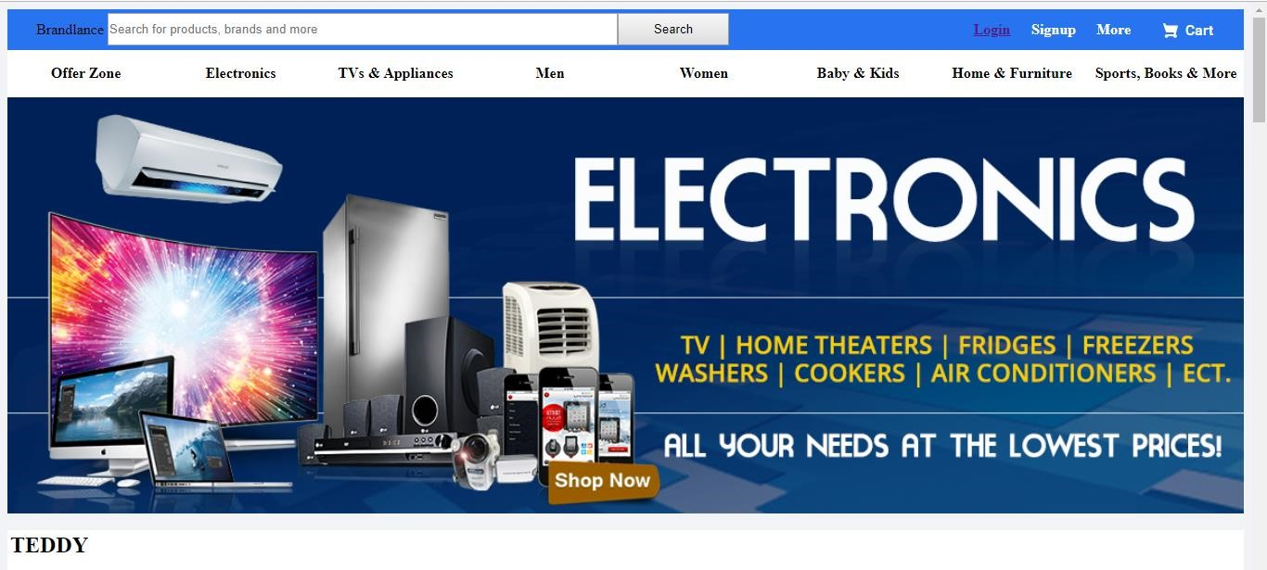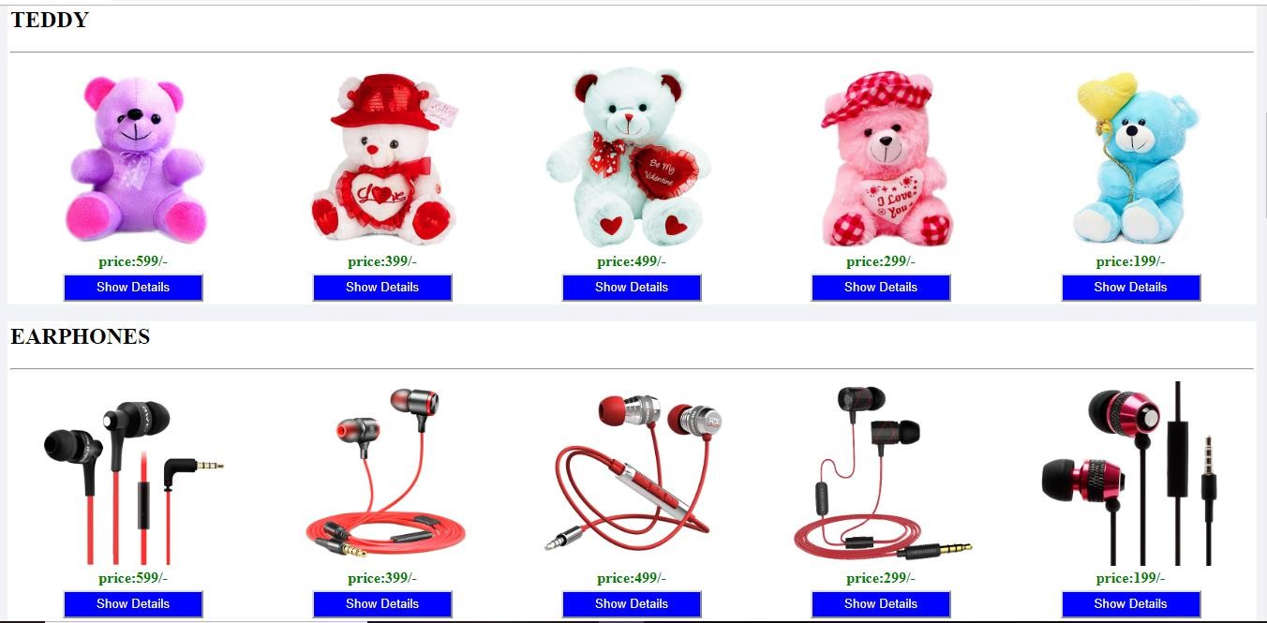

Fig.1 Home

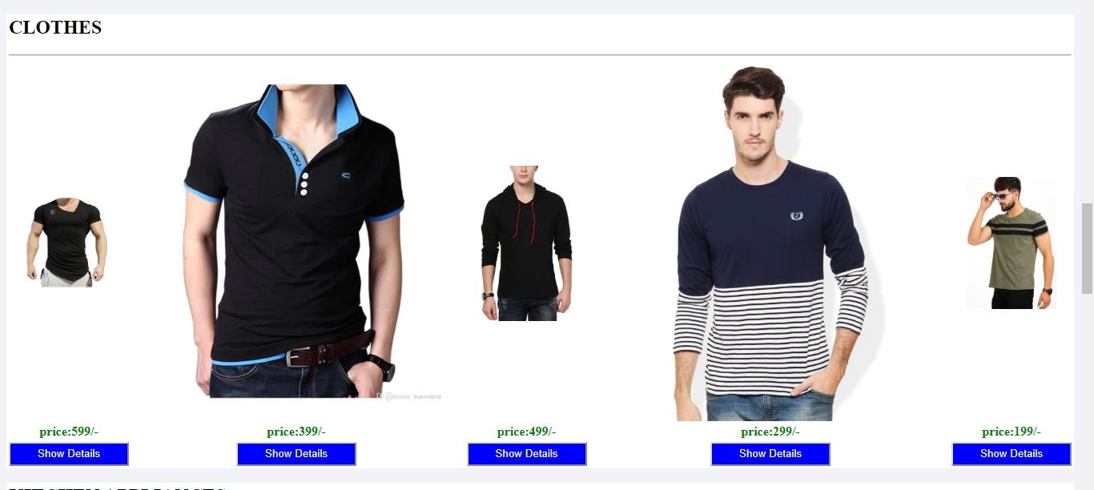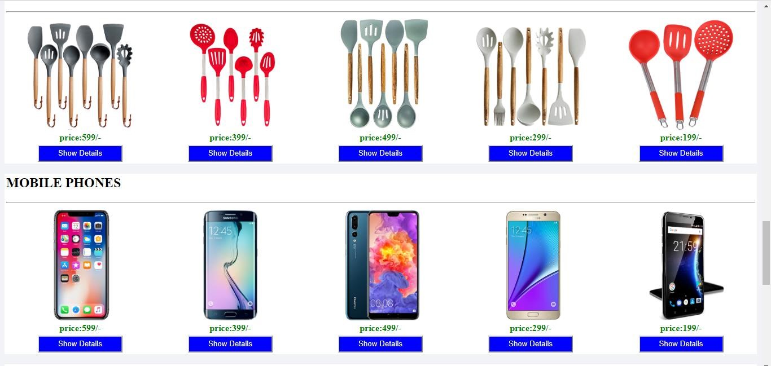

Fig2.Product

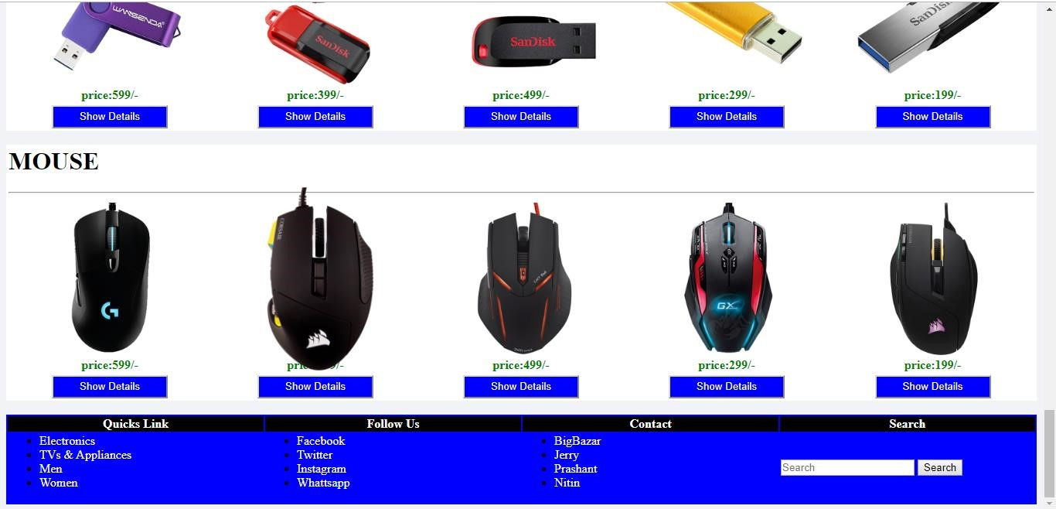

Fig3.Products

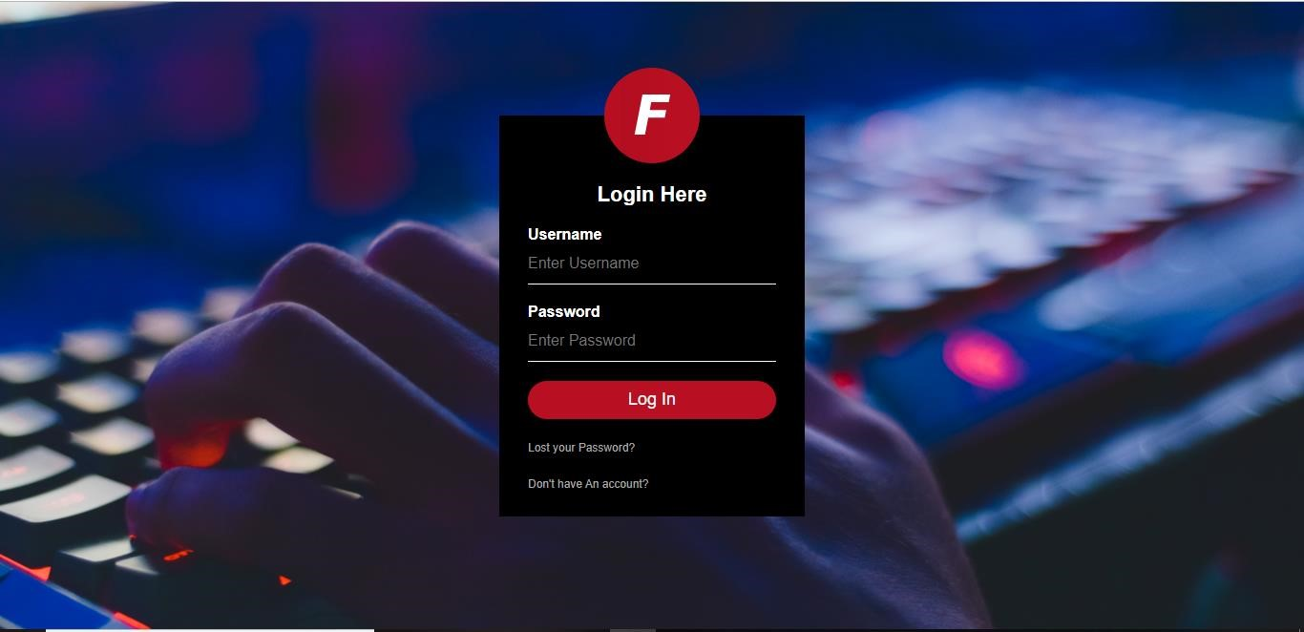

Fig4.Login

Fig5.Signup

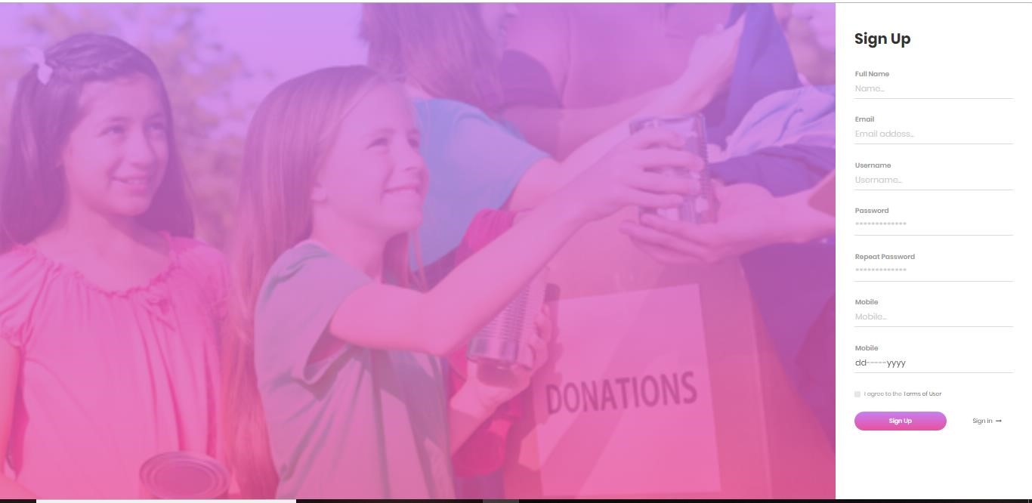

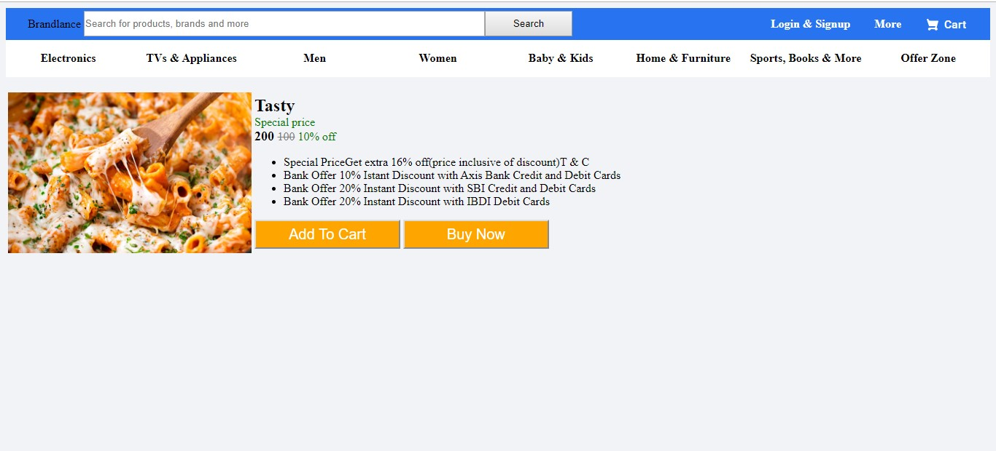

Fig6.Detail Of Products

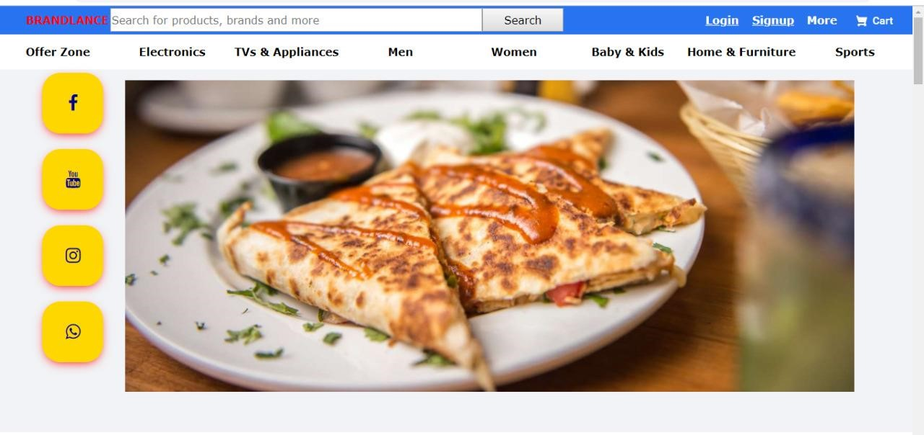

Fig7.Social media buttons

# Bibliography

* www.javatutpoint.in

* www.w3school.in

* www.getbootstrap.in

* www. codeigniter.in

* www.stackoverflow.in

* [www.fontawesome.io](http://www.fontawesome.io/)

* Learn HTML and CSS faster(Mark Myers)

* Wikipedia

# Future Scope

1.Computer Hardware would help each and every person to find any product via our website and get it at home it will save their time.

2.It would provide huge collection of product of all fields.

3.User will also get paynow later option.

4.User will be also get feedback section.

5.We will be providing some special design to our website in future.

# CONCLUSION

In general, today’s businesses must always strive to create the next best thing that consumers will want because consumers continue to desire their products, services etc. to continuously be better, faster, and cheaper.

In this world of new technology, businesses need to accommodate to the new types of consumer needs and trends because it will prove to be vital to their business’ success and survival. E-commerce is continuously progressing and is becoming more and more important to businesses as technology continues to advance and is something that should be taken advantage of and implemented.

From the inception of the Internet and e-commerce, the possibilities have become endless for both businesses and consumers.

Creating more opportunities for profit and advancements for businesses, while creating more options for consumers.

However, just like anything else, e-commerce has its disadvantages including consumer uncertainties, but nothing that can not be resolved or avoided by good decision-making and business practices.

There are several factors and variables that need to be considered and decided upon when starting an e-commerce business.

Some of these include: types of e-commerce, marketing strategies, and countless more. If the correct methods and practices are followed, a business will prosper in an e-commerce setting with much success and profitability.